**Lab-3 (Design of Optical Communication System) – (2 lab sessions)**

**(I-MTech 5th Semester)**

**Introduction**: In this lab you are expected to understand the principle of optical communication and how aTransimpedance Amplifier (TIA) can be used as an optical communication receiver. We will also learn how to design and analyze a TIA, understand its stability aspect and how to design a compensation circuit for a TIA. This optical communication system consists of 2 stages: Transmitter with LED,followed by a receiver photodiode, TIA and comparator circuit.

Reference: Chapter on Stability (Ch. 8) in “Design With Operational Amplifiers And Analog Integrated Circuits-Sergio Franco” textbook.

1. (a). First derive the closed loop gain A(s).β(s) and explain why the circuit is unstable if there is a finite capacitance Cpd (which is the sum of the photo-diode and op-amp parasitic input capacitances) if Cf=0. Do the .AC and .TRAN analysis for the transimpedance amplifier(TIA) circuit shown below without Cf by taking feedback resistance Rf (Closed-loop DC Gain of TIA) ≥ 50kΩ in LTSPICE. Calculate the closed-loop input impedance at DC from the formula derived in class. Using .TF measure the input impedance looking into the input node of the circuit (negative input terminal of the op-amp) and compare with the calculated value.

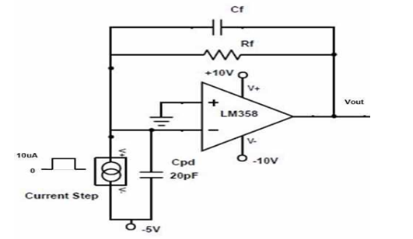

(b). If you observe instability (peaking in the frequency response and over-shoot in the time-domain (step) response) in the above analysis you have to apply frequency compensation. Read the concept of Rate of Closure (ROC) from the reference above and find out the value of feedback capacitance value to make the system stable. Re-do the .AC and .TRAN analysis to ensure the system stability and note down the DC Gain, bandwidth and phase margin of the system.To find the minimum compensation capacitance at which the system become stable, use following equation (derived in the reference text-book):

$$C_{f}= \frac{1+ \sqrt{1+8πf_{u}R_{f}C_{pd}}}{4πf_{u}R_{f}}$$

where fu is unity gain frequency of Opamp. Ensure that after insertion of the compensation capacitance the gain peaking and overshoot do not appear in the closed-loop .AC and .TRAN (step) response.

1. (a). Build the hardwarefor optical communication system as shown below and use the same Rf & Cf values that are chosen for simulations.

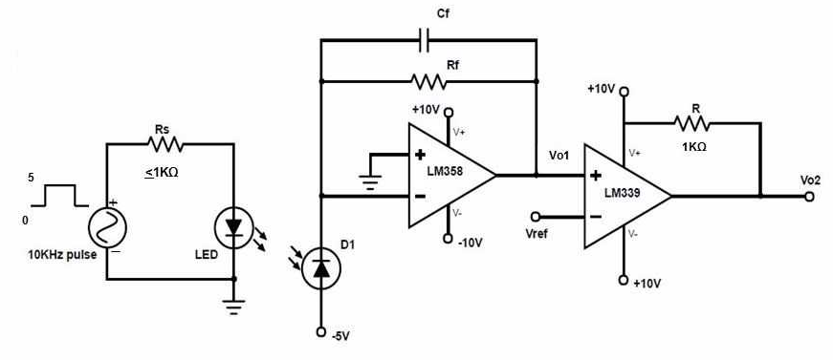

**Note:** Do not expose your LED and Photodiode to outside light, try to cover them with a piece of black paper and make both the LED and photo-diode in same line of sight.

Make the system work and observe the peak-peak range (in 100’s of mV) for the output of TIA with an input square-wave signal of 10kHz. What is the data-rate corresponding to this input signal? Take the average dc value of the TIA output, generate that voltage and apply it to the negative input terminal of the comparator LM339 to generate the proper digital data at its output. And observe the timing deviation from input and final output (Vo2) to measure the delay introduced by the optical system.

(b). Repeat the same procedure for at least two different frequencies say between 50 KHz and 100 KHz, to get to know till what frequency the designed system is working as expected.

(c) For the highest square wave signal used in (b) increase the distance between the LED and photo-diode up to a few cm so that the output of the op-amp (LM358) appears somewhat noisy and the output amplitude of the op-amp is also smaller. What is the cause of the observed decrease in signal-to-noise ratio? Capture the output of the op-amp and comparator in this case.